PRESS INFORMATION

Your press contact:
Jens Augustin
augustin@martor.de
www.martor.com

MARTOR KG
Lindgesfeld 28
42653 Solingen
Germany

2 September 2020

LOADS OF POWER.
THE NEW SAFETY KNIVES FROM MARTOR.

Safe, efficient and comfortable cutting. This is the mission of MARTOR, the leading manufacturer and supplier of high-quality safety knives. The two latest cutting tools from Solingen, the SECUNORM 525 and the SECUNORM 540, exceed in meeting this goal. Both safety knives impress most with their robustness and substantial cutting depths.

The SECUNORM 525 and the SECUNORM 540, with extremely sturdy aluminium handles and cyan-coloured controls, might look like twins. But they have one essential difference. While the SECUNORM 525 (depending on the blade used) has a maximum cutting depth of 21 mm, the SECUNORM 540 has cutting depths up to 36 mm. This difference determines which area of application is best suited for each safety knife.

The SECUNORM 525 is a classic all-rounder for professional users in industry, retail, logistics and craft trades. Multi-ply cardboard, plastic strapping band, film, rubber and PVC all present no problem for the new top performer from Solingen.
The SECUNORM 540, in contrast, reveals its power primarily as a specialist knife for thicker and/or softer materials, such as foam, polystyrene or construction foam.

The reliable automatic blade retraction constantly protects users against cutting injuries. When the thumb is removed from the slider, the blades in the SECUNORM 525 and SECUNORM 540 instantly retract back into the handle as soon as the cutting process ends.

The SECUNORM 525 and SECUNORM 540 are a continuation of MARTOR’s high-performance series of cutting tools. They follow in the footsteps of their successful predecessors SECUNORM PROFI25 and SECUNORM PROFI40 – with major upgrades.
For example, the slider for blade release has been enlarged and optimised, improving comfort for thumb operation. Another new feature on both knives is a blade change button to give users easy access to the blade. Blades are also secured by a magnet to prevent them unintentionally falling out. The blade cover also now has a practical lift and lock feature to hold it in an open position.

These knives show that MARTOR is not only continuing to perfect manual cutting tasks, but also handling of the knives, e.g. by making blade changing as easy and safe as possible.

Characters including spaces: 2,253

Product image

SECUNORM 525
NO. 52500410

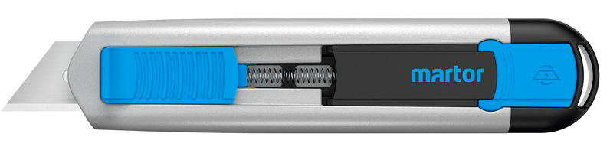

SECUNORM 540
NO. 54000410

